Status REPORT

Table of Contents
Introduction 1
Jenkins pipelines 1
LOB 1
Technology Distribution 1
Build Status 2
Observations 2
Release Naming 2
Sonarqube Configurations 3
Current SCenario 3
Project Naming 3
Next actions 3

Introduction
This report presents the current status of the Jenkins and SonarQube integration initiative, outlining the progress achieved, the governance model implemented, and the next steps required to ensure sustainable code quality and DevSecOps compliance across all projects.
The primary objective of this initiative is to establish a standardized, automated, and enforceable quality control framework within the CI/CD pipeline. By integrating SonarQube analysis into Jenkins pipelines and enforcing Quality Gates, we have transitioned from passive code scanning to active quality governance.
This document summarizes:
- The current implementation status
- Quality Gate enforcement strategy
- Security and compliance scanning integration (SAST, SCA, Secret Scanning)
- Ownership and accountability model
- Dashboard and reporting structure
- Automation of alerts and stakeholder engagement
- Governance framework for management visibility

Jenkins pipelines
This section provides a consolidated inventory of all active Production Jenkins pipelines

LOB
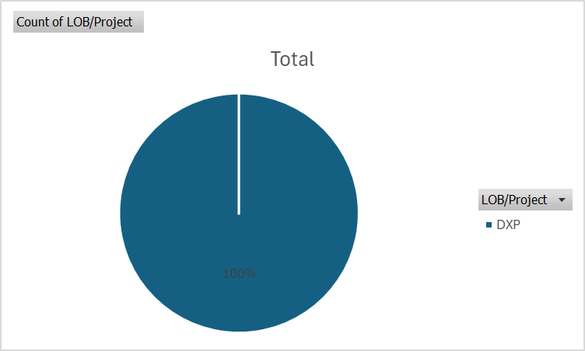

Technology Distribution
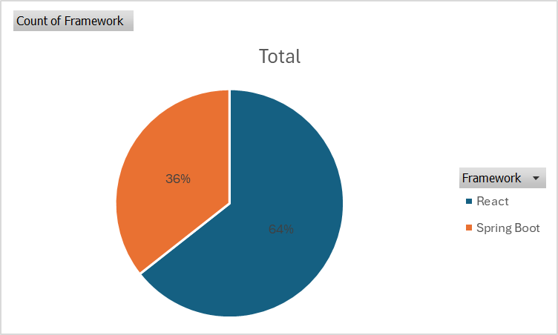

Build Status
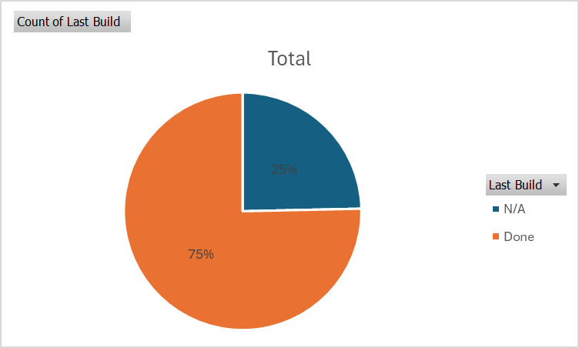

Observations
- production pipelines are still using legacy freestyle jobs.
- Certain pipelines lack quality gate enforcement.
- Pipelines configured with Release Naming with each EPIC related to this release.
- Build and scanning stages are within separate pipelines.

Release Naming
After alignement with Osama, There is already Standard naming policy set for all releases and each release name is mapped to EPIC name.

Sonarqube Configurations

Current SCenario
Right now SonarQube analysis is triggered only by a Bitbucket push event.
So the scan runs:
- independent from the build
- on raw source code only
This creates a gap:
- the scan might not reflect what actually gets built and deployed.

Project Naming
Configure each project with standard naming policy and use the following\
<LOB>-<REPO NAME>
And Set Project Key for each project with related Pipeline Name.

Next actions
- Reconfigure current projects with Sonarqube.
- Configure Quality gates for each technology with required rules.
- Start with pipelines related to specific technology for DEV Pipelines(we can set later) and then we can go with UAT, QC and Prod .
- For each build pipeline, Create a new pipeline with “Pipeline” type and combine Build, Test and Scanning stages within the same Jenkins file.
- Configure each pipeline with related Sonarqube project name based on PROJECT NAMING POLICY.
- Configure Quality Gate for each pipeline to enforce policies.

